Student’s name | …………………………………………………….…… | Grade | 7
Subject | Computer | Week No. | 14
Lesson Title | Data Transfer | Unit
Worksheet No. ( 14 )

Question A: write the correct name of each part.

9V Battery | Jumper Wires | Resistor 10 K ohms
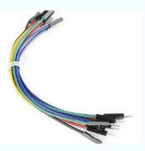
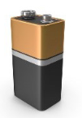
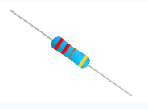
Good Luck

